Fluorescence Microscopy

PC3267

Background
Fluorescence microscopy is used to detect structures, molecules or proteins within the cell. Fluorescent molecules absorb light at one wavelength and emit light at another, longer wavelength. When fluorescent molecules absorb a specific absorption wavelength for an electron in a given orbital, the electron rises to a higher energy level (the excited) state. Electrons in this state are unstable and will return to the ground state, releasing energy in the form of light and heat. This emission of energy is fluorescence. Because some energy is lost as heat, the emitted light contains less energy and therefore is a longer wavelength than the absorbed (or excitation) light.
In fluorescence microscopy, a cell is stained with a dye and the dye is illuminated with filtered light at the absorbing wavelength; the light emitted from the dye is viewed through a filter that allows only the emitted wavelength to be seen. The dye glows brightly against a dark background because only the emitted wavelength is allowed to reach the eyepieces or camera port of the microscope. Most microscopes are designed using epi-illumination. In epi-illumination excitation, light goes through the objective lens and illuminates the object. Light emitted from the specimen is collected by the same objective lens.
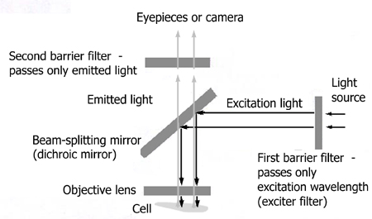
Fig.1 The optical system of fluorescence microscope
The fluorescence microscopes are equipped with three fluorescent filter cubes, each containing specific barrier filters and a beam-splitting mirror. You must be able to change the filter cube. The filter cubes provide UV excitation (2.WU), blue light excitation (3.WB), green light excitation (4.WG).
Before beginning, identify the location of filter cubes, and camera controls. Observe the cells in Bright field first, then switch to the UV filter set as the dye is UV-excited. As you observe the cells, make notes on the morphology and location of the stained material within the cell. That is, determine the structural organization and localization of the organelles. Collect the best images using the software.

Cells
  - onion skin epidermal cells
  - human epithelial cells taken from the lining of the cheek
Cell preparation:
- Onion Cells
Slice a raw onion cut into about 5 mm sections. Remove the inner transparent membrane with a forceps. Onion cells are nicely stained with Hoechst stain in a small plate. Incubate 15 mins and observe with fluorescence microscopy. The nuclei will appear blue.
- Cheek Cells
Gently scrape the inner lining of the cheek with the flat end of a toothpick. Transfer the cells to a small drop of PBS on a slide. Then stain the cell with Hoechst. Incubate 15 mins and observe with fluorescence microscopy.
Bright Field Microscope

1. Turn on power supply (both).
2. Place glass slide on the slide holder. Cover slip should face down.
3. Change object lens to a desired magnification.
4. Turn on power source for bright field. The shutter should be closed.
5. Change the view to eye piece.
6. Adjust brightness and focus:
a) Inner large knob for coarse tuning
b) Outer small knob for fine tuning.
7. Adjust sample position by adjusting top and bottom knob.

Fluorescent Microscope:

- Turn off bright field power switch.
- Change filter to WU (No.2).
- Open the shutter.
- Change view to camera.

Software for taking image

- Click on DP controller.
- Click acquire button or press F7.
- Focus on sample.
- Add scale bar in scale tab. Click “Show Scale”. Resize scale bar to 20µm.
- Go back to capture tab.
- Change the scale objective to the magnification you use.
- Select exposure mode to manual. Change exposure time to get a clear picture.
- Click capture or press F8 to capture sample photo.
- Save the image.

Results analysis
- Compare the structure, size and morphology of above two kinds of cells. Discuss what are the major differences between plant and animal cells.
- Discuss the benefits of fluorescent microscope over standard optical microscopy (bright field microscopy)

